Chapter 13, Problem 19.

Determine an equivalent T-section that can be used to replace the transformer in Fig. 13.88.

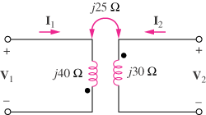

Figure 13.88
For Prob. 13.19.

